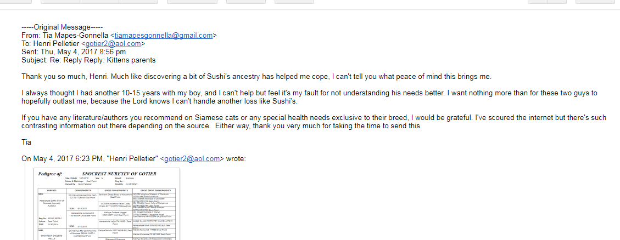
RE: 1705-19166/DJS/ATTACHMENT 5

